
Crime and Punishment

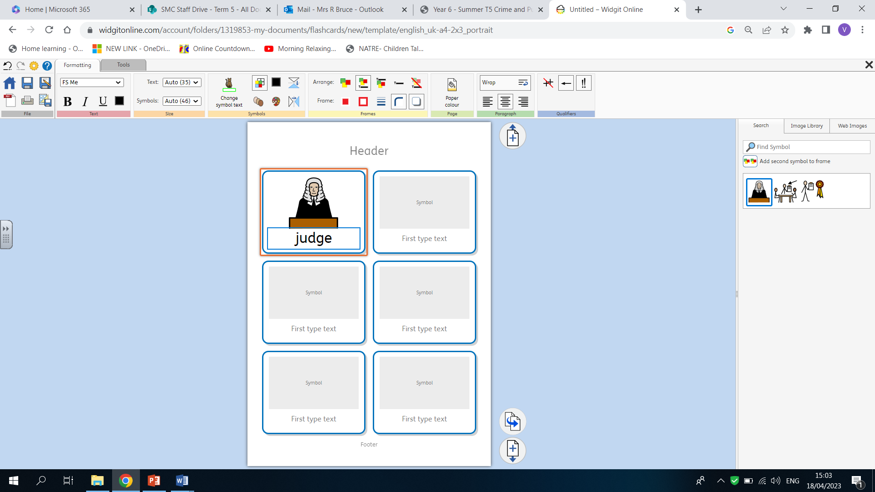
History
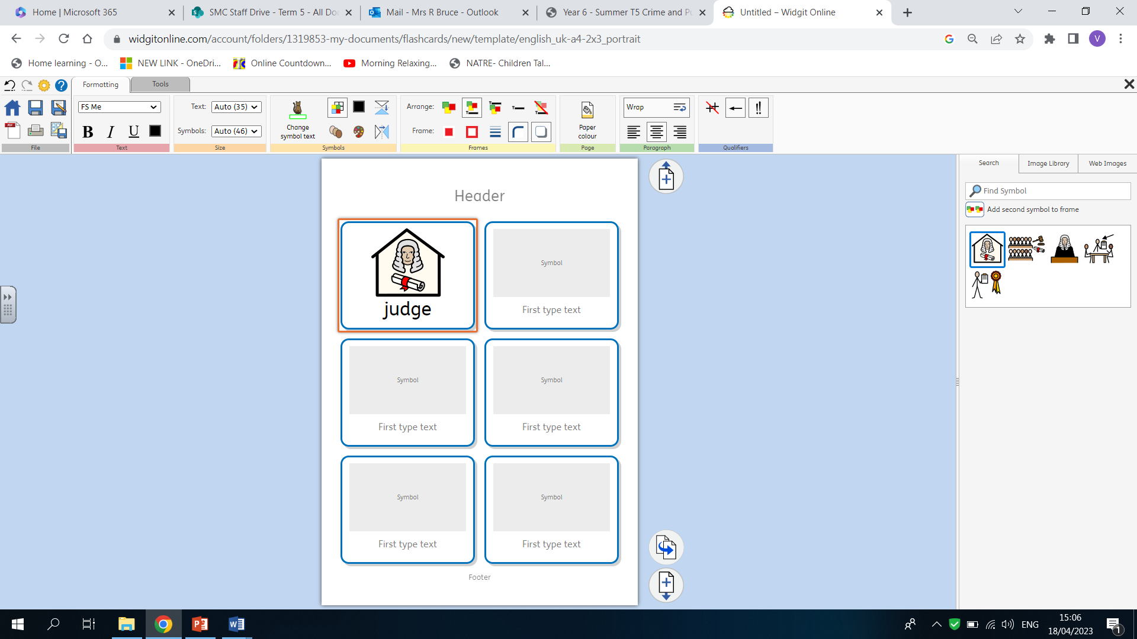
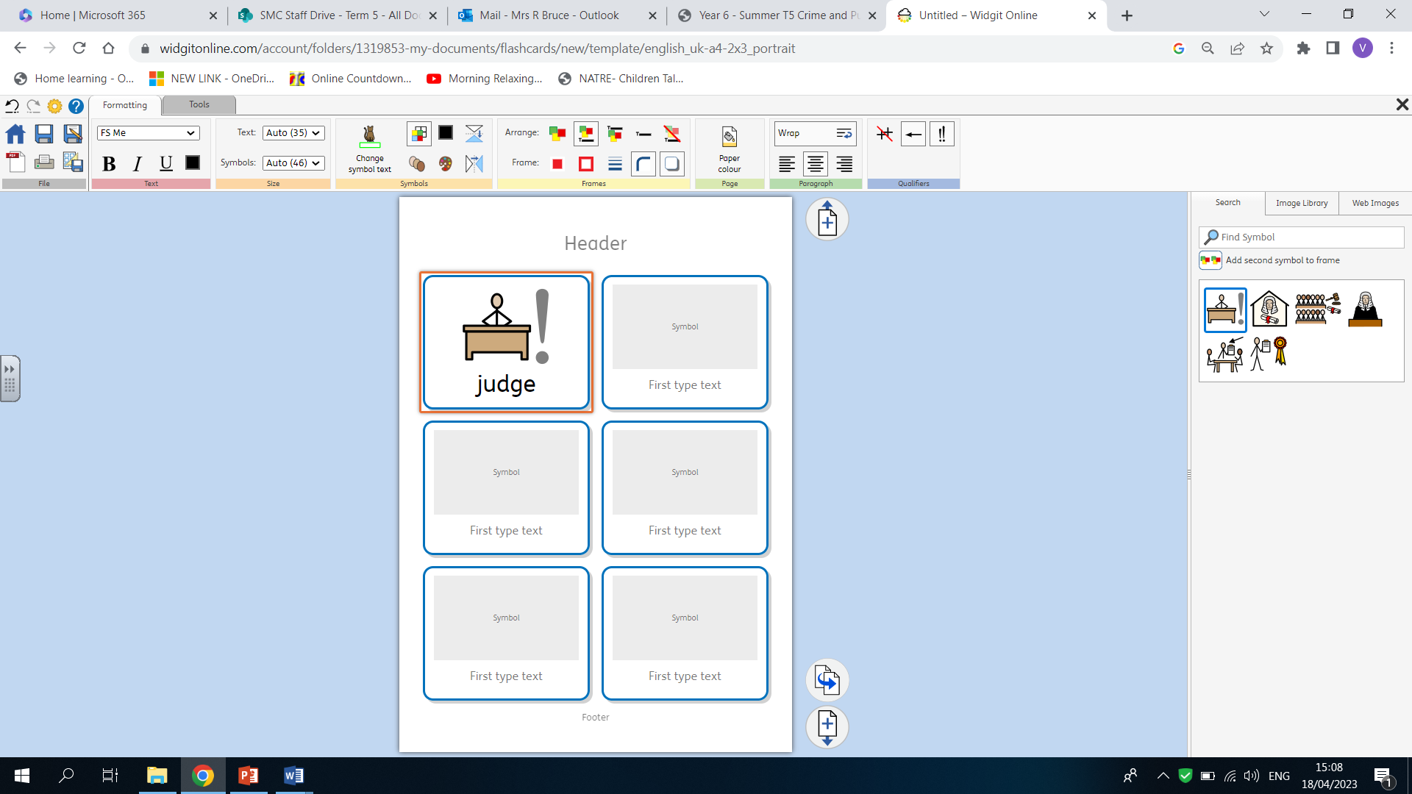
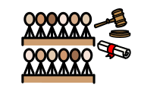
Year 6Term 5

- I know how to use specific time vocabulary.
- I have knowledge and understanding of the Roman, Anglo-Saxon, Tudor and Victorian eras and know how to order these periods in history chronologically.
- I know how events in history have shaped our lives.
- I know how sources of information help us to answer questions.
- I know how to present my own findings both orally and in writing.

What should I already know?

Key Vocabulary
What am I going to learn? (Sticky Knowledge)

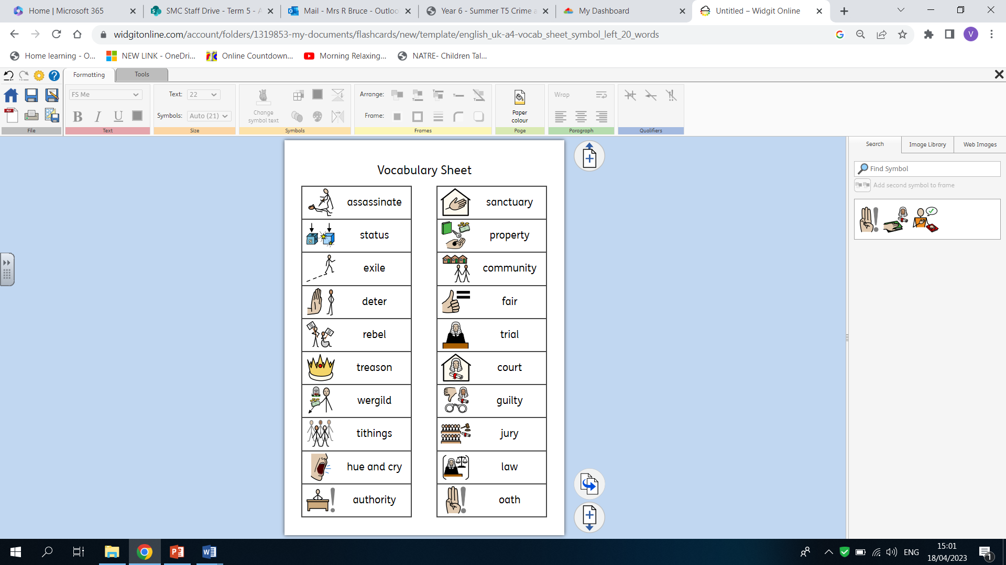

- To know how to use the appropriate dates for the time studied.

- To know how to make comparisons between historical periods, explaining things that have changed and things that have stayed the same.

- To know how to describe the similarities, changes and continuity between different periods in history.

- To know how crime and punishment has changed over time.

- To know how to debate the morality of crime and punishment through different periods in history.

