

Eco Warriors

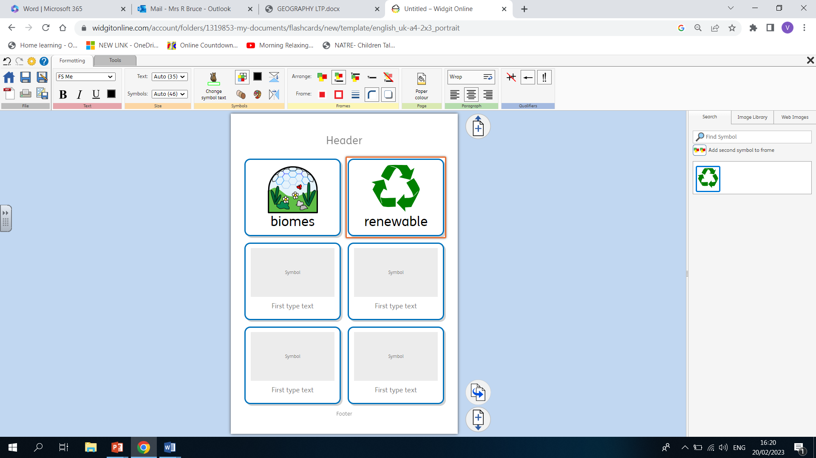
Geography
Year 6 Term 4

What should I already know?
- I know how to use maps and atlases to locate countries and major cities around the world.
- I know and can explain the term ‘physical geography’.
- I know and can explain the term ‘human geography’.

Key Vocabulary
What am I going to learn? (Sticky Knowledge)

- To know how to use maps and atlases accurately.
I can identify different biomes located around the world.

- To know key aspects of physical geography.
I know and can describe the features of different biomes.
I can identify how biomes around the world are changing.
I can identify climate zones and describe how these are changing.

- To know key aspects of human geography.
I can identify and describe the human impact on biomes and climate zones.
I can describe how changing biomes are affected by human geography.
I can describe the affect of human geography on our future world.



