How do people use animal patterns in art?


· Art · Term 4 ·

* To know what a repeating pattern is.
* The names of primary and secondary colours.
* How to use different media create different marks.

What should I already know?

To know:
- To know that different brushes and strokes can create different marks.
- To know how to mix primary colours to make secondary colours
- To know how to make tints by adding white
- To know how to make tones by adding black

What am I going to learn?

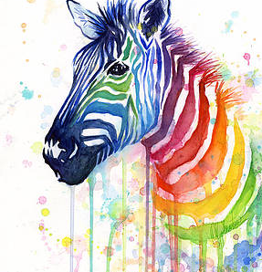
Key Vocabulary



