Happily Ever After


· Design and Technology · Term 3 ·

* The names of everyday materials. * How to draw a range of shapes.
* How to use scissors. * How to fix materials together.

What should I already know?

To know:
- How to design my own castle.
- How to select from a range of materials and components.
- How to connect, attach and construct items.
- What a mechanism is.

What am I going to learn?

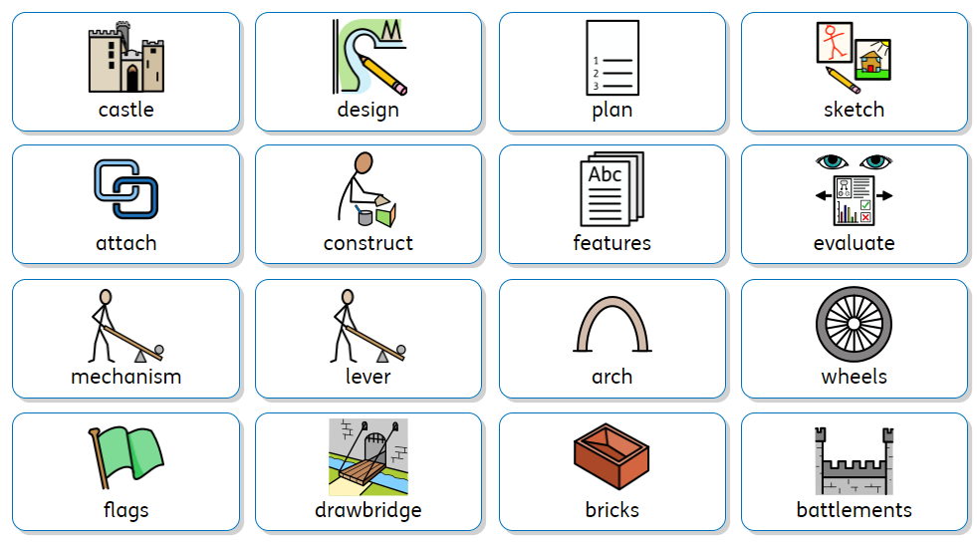
Key Vocabulary

