
London’s Burning
Year 2 - Knowledge Organiser
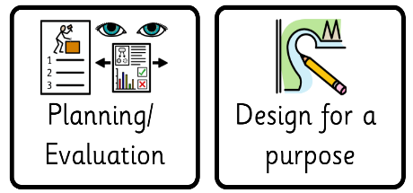
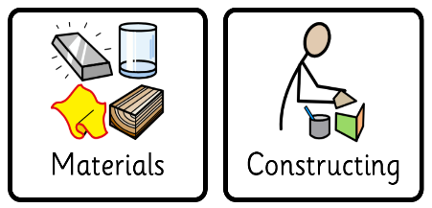
D.T
Term 2

What should I already know?
- To know some different techniques for joining different materials.
- To know how to use materials and tools with care and precision.

- To know how to select from and use a range of tools and equipment to perform practical tasks.

What am I going to learn?
I am going to learn:
- To know how to select from and use a wide range of materials and components, including construction materials, textiles and ingredients, according to their characteristics.
- To know how to develop ideas by drawing and planning.
- To know how to select from and use a range of tools and equipment to perform practical tasks (for example, cutting, shaping, joining and finishing).
- To know how to plan and design for a specific purpose.

Key Vocabulary

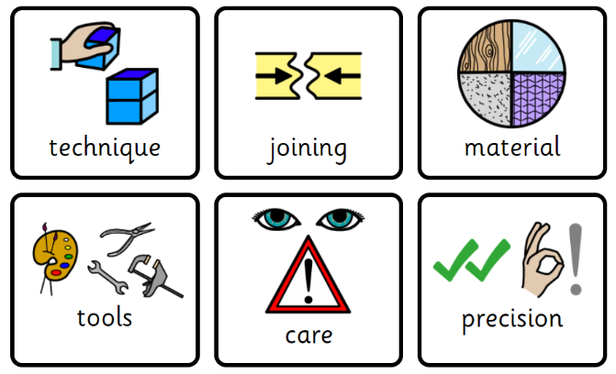

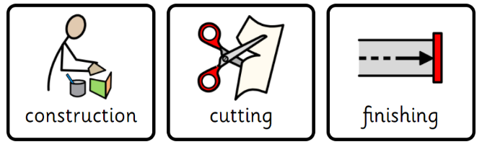

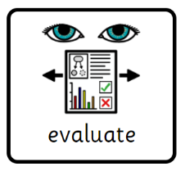

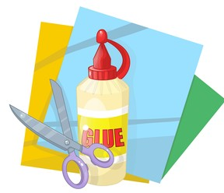
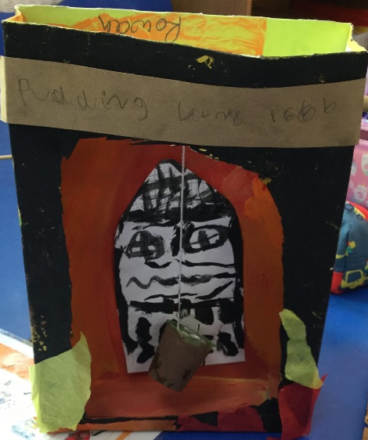

Great Fire of London D.T Box



