Dreams and Goals
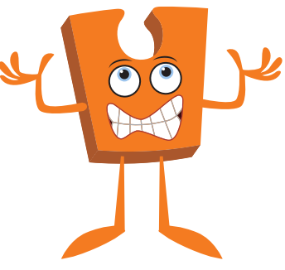


· Jigsaw · Term 3 ·
What should I already know?

* What a goal is. * What a dream is.

- How to set simple goals.
- How to set a goal and work out how to achieve it.
- How to solve problems with a partner.
- How to identify obstacles which make it difficult to achieve my goal.
- How to overcome obstacles.

What am I going to learn?


Key Vocabulary


