Healthy Me


· Jigsaw · Term 4 ·

* To know my different body parts and how to keep them clean.

What should I already know?

To know:
- The difference between being healthy and unhealthy.
- To know some ways to keep myself healthy.
- That germs cause disease/illness.
- That all household products including medicines can be harmful if not used properly.
- Understand that medicines can help me.
- How to keep safe when crossing the road.
- Why I think my body is amazing.

What am I going to learn?

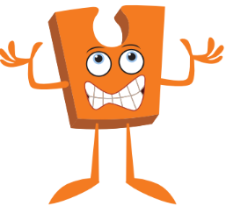
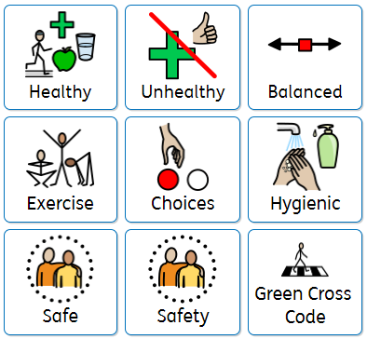

Key Vocabulary







