
Being Me in My World
Year 2 - Knowledge Organiser
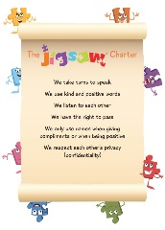
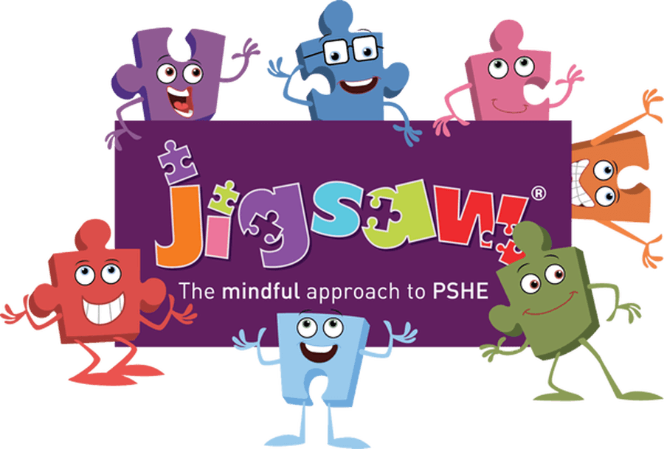

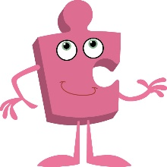
Jigsaw
Term 1

What should I already know?
- To know the rights and responsibilities of being a member of my class.
- To know my views are valued and can contribute to the Learning Charter.
- To know and recognise the choices I make and understand the consequences.

Key Vocabulary

What am I going to learn?
I am going to learn:
- To know how to identify some of my hopes and fears for this year.
- To know the rights and responsibilities for being a member of my class and school.
- To know how to listen to other people and contribute my own ideas about rewards and consequences.
- To know how following the Learning Charter will help me and others learn.
- To know I can recognise the choices I make and understand the consequences.



