
Celebrating Differences
Year 2 - Knowledge Organiser
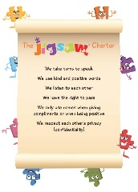
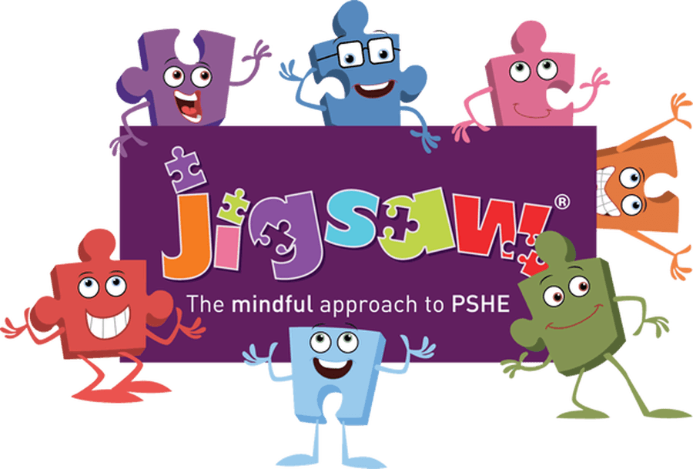
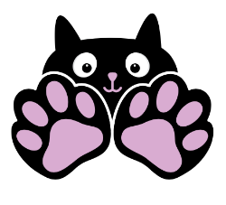
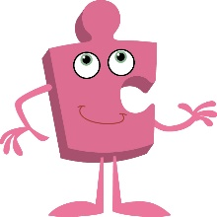
Jigsaw
Term 2

What should I already know?
- To know how to identify similarities between people in my class.
- To know how to identify differences between people on my class.
- To know what bullying is.
- To know which people I can speak to if I feel unhappy or being bullied.
- To know how to make new friends.
- To know how I am different to my friends.

What am I going to learn?
I am going to learn:
- To know and accept that everyone is different.
- To know how to help someone if they are being bullied.
- To know how to solve problems
- To know and recognise what is right and what is wrong.
- To know that it’s ok to be different from others.
- To know how to give and receive compliments.

Key Vocabulary



