
Dreams and Goals
Year 2 - Knowledge Organiser
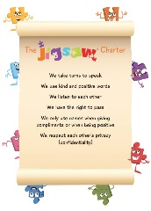
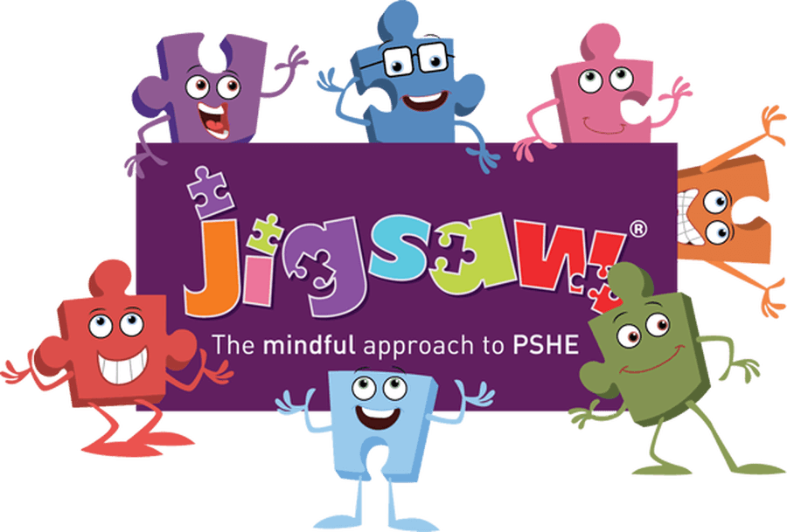

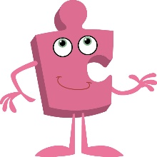
Jigsaw
Term 3

What should I already know?
- To know how to set simple goals.
- To know how to set out a simple goal and think about how to achieve it.
- To know how to work well with a partner.
- To know that new challenges might stretch my learning.
- To know how to identify obstacles and work out how to overcome them.
- To know how to store feelings of success in my internal treasure chest.

What am I going to learn?
I am going to learn:
- To know set realistic goals and think about how to achieve them.
- To know how to persevere when finding things difficult.
- To know how working together with others helps me learn.
- To know how to work with others in a group to solve problems.
- To know how to share successes with others in a group.
- To know how to evaluate and reflect on a group task.

Key Vocabulary



