
Living Things
and Their Habitats
Science Term 4

- To understand that living things can be grouped in a variety of ways.
- To understand how to use classification keys.
- To know a variety of living things in their local and wider environment.
- To understand that changes in environments can occur and can sometimes pose dangers to living things.
- To know how to use the local environment to study plants and animals in their habitats.
- Know how habitats change through the year.

What should I already know?

What am I going to learn? (Sticky Knowledge)

- To be able to look at subdivisions within a class of living things.
- To know how animals and plants are adapted to suit their environment in different ways and that adaptation may lead to evolution
- Understand and give reasons why living things are classified into groups according to their characteristics, similarities and differences (micro-organisms, plants and animals).

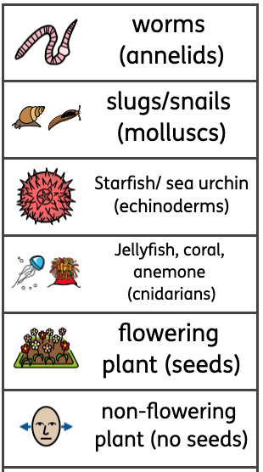
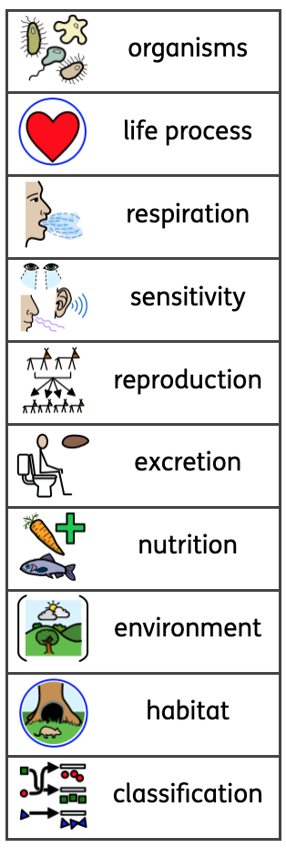
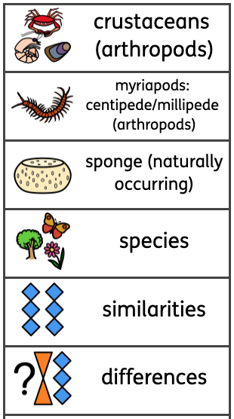
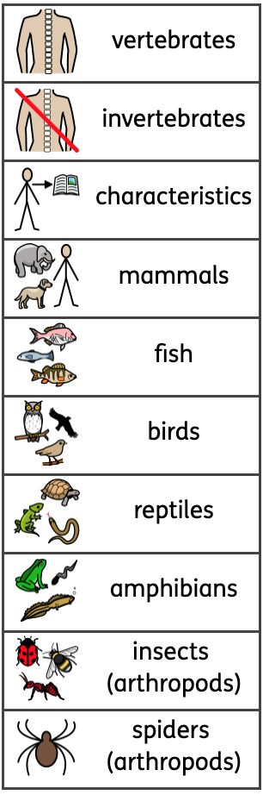

Key Vocabulary


