
Animals Including Humans
Science Term 5

- To know that the teeth of carnivores and herbivores are different.
- To know main parts and the simple functions of the digestive systems in humans.
- To know the simple functions of different types of teeth in humans

What should I already know?

- To understand the ways in which nutrients and water are transported, within animals, including humans.
- To know the main parts of the human circulatory system.
- To understand the functions of the heart, blood vessels and the blood.
- To understand the impact of diet, exercise, drugs and lifestyle on the way their bodies function.

What am I going to learn? (Sticky Knowledge)

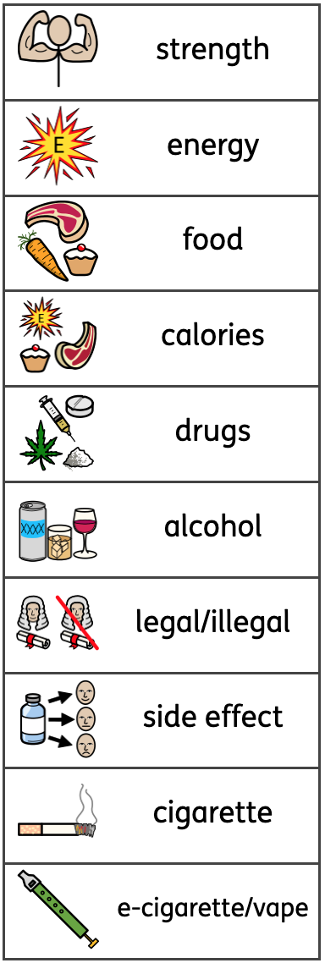
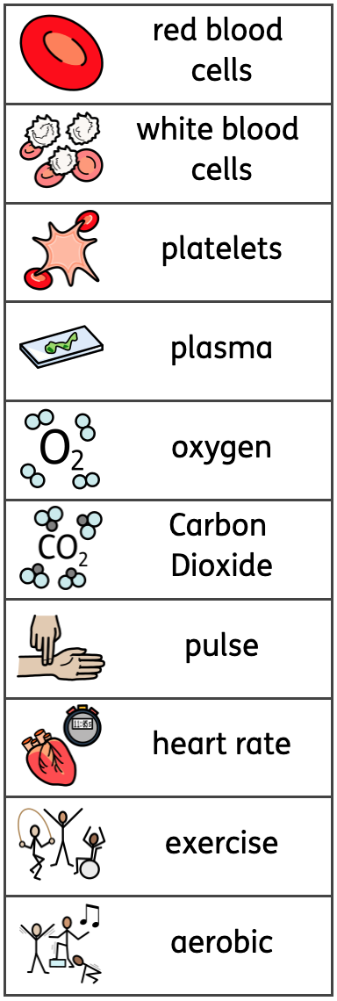
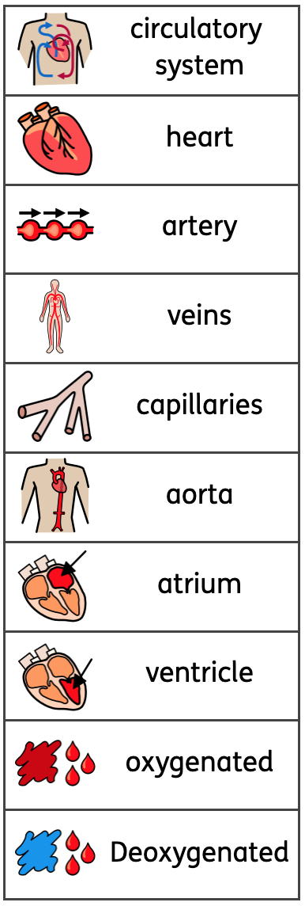

Key Vocabulary


